Fields of Fire
Chatsworth Island would not be the same without the cane surrounding the village. In 1863 the first settler to plant cane at Chatsworth was Hannibal McFarlane. It is believed he planted seven stools of Green Ribbon cane.
The first cane gang to cut cane was Joe Conneally’s using billhooks. The cane was then bundled and taken by horse and cart to the river bank where a derrick crane would load the cane onto the punts for the journey upriver to the mill. The first private mill is believed to have been built by Angus Macmillan in 1879. The original Chatsworth Island mill was dismantled and moved to Harwood around 1900.
Today things have changed a lot. The cane farmers use machines to harvest the cane and then trucks transport it to the mill at Harwood for processing.
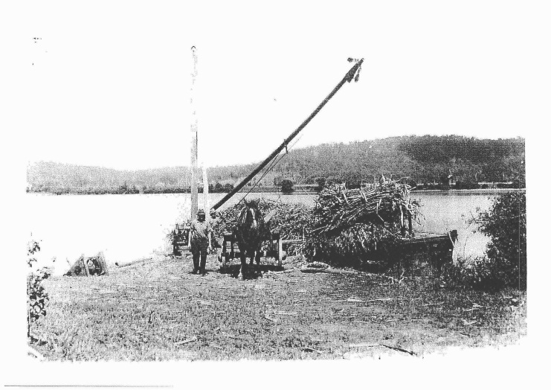
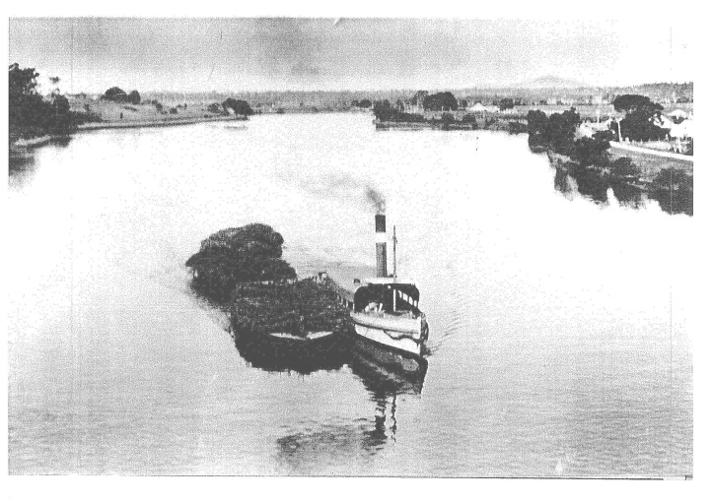
The 1987 mini-series “Fields of Fire” was filmed in and around our school and if you’re lucky you can still get to see the cane fires burning at night between August and October. They are an awesome sight!

Loading cane with the derrick crane ( 1920’s ) Cane on the way to the mill ( 1920’s )

